Local Evaluation for Central Decatur, Lamoni, Mormon Trail
2019-2020
Overview
To assist grantees with meeting the local evaluation requirements, the Iowa DOE provides a standardized form for local evaluations of the 21st CCLC Programs. Each grantee is required to complete the local evaluation form with data from the previous school year. Each grantee must submit ONE evaluation that encompasses all centers funded by the grantee. Cohorts 9-13 are to be included for reporting data for the previous school year. Reported data will be from the Summer, Fall, and Spring .
The table below lists the eight required sections of the local evaluation. Each section includes a checklist of required items to include.
The completed form should be saved with the filename <Grantee Name 21st CCLC Local Evaluation Form 2019-2020>. The form must be completed and submitted in Word format.
(Note: Instructions and clarifications are shown in RED.)
Required Section | Complete?
- General Information | x
- Introduction/Executive Summary | x
- Demographic Data | x
- GPRA Measures | x
- Local Objectives | x
- Anecdotal Data | x
- Sustainability Plans | x
- Summary and Recommendations | x

- General Information
General Information Required Elements | Complete?
Basic Information Table | x
Center Information Table | x

Basic Information Table
Item | Information
Date Form Submitted | February 9, 2021
Grantee Name | Central Decatur CSD
Program Director Name | Amy Whittington
Program Director E-mail | amy.whittington@centraldecatur.org
Program Director Phone | 641-446-4452
Evaluator Name | Ann Schlapia
Evaluator E-mail | annmschlapia@gmail.com
Evaluator Phone | 641-202-4828
Additional Information from Grantee (optional)

Center Information Table
Cohort | Centers
(If not in a cohort, leave that cohort info blank) | (Enter Names of Centers, separated by commas)
Cohort 10
Cohort 11
Cohort 12 | CD South Elem, CD North Elem, Lamoni Elem, Mormon Trail Elem
Cohort 13
Cohort 14
Additional Information from Grantee (optional)

Note: If you are in Cohort 15, you will report your data next year (We always report the previous year’s data in the local evaluations).

- Introduction/Executive Summary
Introduction/Executive Summary Required Elements | Complete?
Program Implementation
- Needs Assessment Process | x
- Key People Involved | x
- Development of Objectives | x
Program Description
- Program days and hours | x
- List of activities | x
- Location of centers | x
- Attendance requirements | x
- Governance (board, director, etc.) | x
Program Highlights | x

Type or copy and paste Introduction/Executive Summary here.
Cardinal Muscle and the Saints After-school Program represent a collaborative project resulting from the combined efforts of Central Decatur Community School District and the Mormon Trail Community School District. They had a very successful program in grant cycle eight with numerous benefits for all involved. In grant cycle twelve, another local district was added, Lamoni Community School District. This center is also located in Decatur County and shares a superintendent with Central Decatur CSD. High poverty numbers and isolation were compelling reasons to expand the grant to include students in this district. Close proximity and shared governance were strong factors in the consideration of this expansion as well. The addition of this district allows the benefits of shared resources (many community members cross over in a variety of roles), as well as enables all children in Decatur County to be provided with much needed services.
The partners share resources, responsibilities, and risks related to the 21st Century program. Each site contributes to the grant’s operations, programming and quality corresponding with individual areas of expertise and mission alignment. The project is closely aligned with each district’s goals as well as the overall CSIP goals of creating a safe learning environment and increasing math and reading achievement. Intentionally designed intervention activities for reading and math are purposefully integrated into the program. After-school tutoring is closely connected with individual student goals in order to remediate any reading or math deficiencies. Reading comprehension and vocabulary strategies and math problem solving are regularly utilized to help students meet their proficiency goals. A unique feature of the four 21st CCLC centers is the close alignment of the project goals with the student's daily achievement to best help promote and sustain student success. Each of these goals are designed to help with the early identification of students who need intervention and provide those students with individualized interventions that target the specific areas of student need.
The Decatur County Coalition Committee was established to serve as the collaborative board. This group has quarterly meetings throughout the past year to provide guidance, consistency, and support for all four centers.
All centers have established before school programs which allow an intentional time for teachers and staff to touch base with students. This practice ensures the development of positive relationships and engenders a positive start for everyone’s school day. Throughout the past several years, teachers have undergone training with Carol Dweck’s growth mindset materials and Ruby Payne’s poverty framework. These are employed in the early morning time together to hopefully bridge any issues that students may carry from home as they transition into their school day; it also supports their social-emotional growth and learning.
Dynamic and well-organized after school programs are offered at all sites. All programs begin as soon as school dismisses and last until 5:30 p.m. The existing sites offered summer academic maintenance and academic enrichment programs. Program delivery differs slightly at each site in order to accommodate unique community differences and to maximize the opportunity to facilitate student success; however, each center has depended on four groups for staffing.
Four sites in Decatur County meet the needs of area students: Lamoni Elementary in Lamoni, Ia, South Elementary and North Elementary sites in Leon, IA and Mormon Trail Elementary in Humeston, IA. Any Kindergarten through sixth grade student attending school at Lamoni, Central Decatur or Mormon Trail is eligible to attend programming at no cost.
Mormon Trail offers before school programming Monday through Friday from 7:00-8:00 am. After school programs run Monday through Thursday from 3:30-5:30pm, and early out Fridays, twice a month, programming is provided from 1:00-5:30pm. Lamoni offers a before and after school program for students in the elementary, grades kindergarten to fifth grade, Monday through Friday. The before school program runs from 7-8 am. The after school program runs from 3-5 pm. On Friday early outs, the program runs from 1-4 pm. Central Decatur offers a morning and afternoon program for students at both North and South Elementary. Our morning program runs from 7:00-8:00 Monday through Friday. The afternoon program runs from 3:00-5:30 Monday through Thursday. If our school has an early out for Teacher Professional Development or Parent Teacher Conferences, Cardinal Muscle provides programming on those days from 12:45-5:30.

- Demographic Data
Demographic Data Required Elements | Complete?
2019-2020 School Year Attendance Tables | x
- 2019-2020 School Year Attendance Summary Table | x
- 2019-2020 School Year Attendance Ethnicity Table | x
- 2019-2020 School Year Attendance Special Needs Table | x
Summer of 2019 Attendance Tables
- Summer of 2019 Attendance Summary Table | x
- Summer of 2019 Attendance Ethnicity Table | x
- Summer of 2019 Attendance Special Needs Table | x
Attendance Discussion | x
Partnerships | x
- Partnerships Table | x
- Partnerships Discussion | x
Parent Involvement Information and Discussion | x

2019-2020 School Year Attendance. Enter data in the appropriate fields in the tables below. Data will be from the Fall of 2019 and the Spring of 2019. There are separate tables for the Summer of 2019. Leave blank any cohorts that do not apply.
21st CCLC Program 2019-2020 School Year Attendance Summary Table
Cohort | Attendees | Total Attendance | Male | Female
Leave Blank if NA |  | Enter # | Enter # | Enter #
Cohort 10 | All
 | Regular*
Cohort 11 | All
 | Regular*
Cohort 12 | All | 132 | 67 | 65
 | Regular* | 113 | 55 | 58
Cohort 13 | All
 | Regular*
Cohort 14 | All
 | Regular*
*Regular Attendees have attended the program for 30 or more days.
21st CCLC Program 2019-2020 School Year Attendance Ethnicity Table
Cohort | Attendees | White | Hispanic/  Latino | American  Indian/  Alaska  Native | Black/  African  American | Asian/  Pacific  Islander | Unknown  Race
Leave Blank if NA |  | Enter # | Enter # | Enter # | Enter # | Enter # | Enter #
Cohort 10 | All
 | Regular*
Cohort 11 | All
 | Regular*
Cohort 12 | All | 118 | 6 | 0 | 8 | 0
 | Regular* | 112 | 0 | 0 | 1 | 0
Cohort 13 | All
 | Regular*
Cohort 14 | All
 | Regular*
*Regular Attendees have attended the program for 30 or more days.

21st CCLC Program 2019-2020 School Year Attendance Special Needs Table
Cohort | Attendees | LEP | Free and Reduced Price Lunch (FRPL) | Special Needs
Leave Blank if NA |  | Enter # | Enter # | Enter #
Cohort 10 | All
 | Regular*
Cohort 11 | All
 | Regular*
Cohort 12 | All | 0 | 81 | 17
 | Regular* | 0 | 77 | 24
Cohort 13 | All
 | Regular*
Cohort 14 | All
 | Regular*
*Regular Attendees have attended the program for 30 or more days.
Summer of 2019 Attendance. Enter data in the appropriate fields in the tables below. Data will be from the Summer of 2019 ONLY. Leave blank any cohorts that do not apply.
21st CCLC Program Summer 2019 Attendance Summary Table
Cohort | Attendees | Total Attendance | Male | Female
Leave Blank if NA |  | Enter # | Enter # | Enter #
Cohort 10 | All
 | Regular*
Cohort 11 | All
 | Regular*
Cohort 12 | All | 115 | 54 | 61
 | Regular* | 59 | 29 | 30
Cohort 13 | All
 | Regular*
Cohort 14 | All
 | Regular*
*Regular Attendees have attended the program for 30 or more days.
21st CCL Program Summer 2019 Attendance Ethnicity Table
Cohort | Attendees | White | Hispanic/  Latino | American  Indian/  Alaska  Native | Black/  African  American | Asian/  Pacific  Islander | Unknown  Race
Leave Blank if NA
Cohort |  | Enter # | Enter # | Enter # | Enter # | Enter # | Enter #
 | All
Cohort 10 | All
 | Regular*
Cohort 11 | All
 | Regular*
Cohort 12 | All | 112 | 3 | 0 | 0 | 0
 | Regular* | 48 | 4 | 0 | 7 | 0
Cohort 13 | All
Cohort 14 | Regular*
 | Regular*
*Regular Attendees have attended the program for 30 or more days.

21st CCLC Program Summer 2019 Attendance Special Needs Table
Cohort | Attendees | LEP | Free and Reduced Price Lunch (FRPL) | Special Needs
Leave Blank if NA |  | Enter # | Enter # | Enter #
Cohort 10 | All
 | Regular*
Cohort 11 | All
 | Regular*
Cohort 12 | All | 0 | 85 | 13
 | Regular* | 0 | 36 | 6
Cohort 13 | All
 | Regular*
Cohort 14 | All
 | Regular*
*Regular Attendees have attended the program for 30 or more days.
Attendance Discussion.
Attendance Discussion Required Elements | Complete?
General discussion on attendance including
- Percentage of 21st CCLC attendance compared to total population. | x
- Percentage of attendees who are FRPL. | x
- Efforts to increase and keep attendance high. | x
- Recruitment efforts. | x
- Discussion on how contact hours requirement is being met. 60 hours per month (3 hours per day x 5 days a week) during weeks when school is in session (not counting Christmas or Spring Break)  - Explain WHY attendance met or did not meet grant goals. | x

Attendance demographics in all categories mirrors actual enrollment. Elementary enrollment between the 4 building sites is about 600 students for 2019, so program enrollment is about 20% as regular attenders, and another 20% of students attending less frequently. This is significant because it emphasizes the importance of the programming within the larger community. The sites average between 58-69% free and reduced lunch in the overall school population, while 75% of those attending the program are eligible for free and reduced lunch.
Mormon Trail offers a before school program Monday through Friday from 7:00 to 8:00 am. We offer an after school program Monday through Thursday from 3:30-5:30 pm. On early out Fridays (every other Friday) we offer an after school program from 1:00-5:30 pm. We have had success in our numbers that stayed for after school. Parents really enjoyed the help that students received on homework, which made them more successful in school. Younger students were given time to play in centers and participate in activities at their level. We have found at our site that parents want their students to receive help on homework more than anything else.
Lamoni offers a before and after school program for students in the elementary, grades kindergarten to fifth grade, Monday through Friday. The before school program runs from 7-8 am. The after school program runs from 3-5 pm. On Friday early outs, the program runs from 1-4 pm. The program has made efforts to recruit students by sharing information in the elementary school newsletter, the Lamoni school website, and on Facebook to the local community. Additionally, efforts have been made to recruit students through collaboration with Lamoni elementary school teachers. After school events have been collaboratively planned and implemented, such as literacy week during the day, leading up to Family Literacy night where the entire elementary student body is invited in addition to program participants. Efforts have been made to maintain participant attendance by offering a variety of activities, including STEM, homework help, and physical activity daily. Additionally, parents and guardians are often asked for input and suggestions to improve participants' experience and to meet the specific needs of the families with students attending. Finally, to maintain attendance, there is ongoing communication with parents and guardians through email, Remind application, and monthly newsletters to communicate events, activities, and announcements so that families are aware and connected with the program.
Central Decatur offers a morning and afternoon program for students at both North and South Elementary. Our morning program runs from 7:00-8:00 Monday through Friday. The afternoon program runs from 3:00-5:30 Monday through Thursday. If our school has an early out for Teacher Professional Development or Parent Teacher Conferences, Cardinal Muscle provides programming on those days from 12:45-5:30. All programs are free of charge to all families. We have found that the attendance in all programs has stayed consistent, showing us that what we are providing is meeting the needs of our students and families.
Each program would like to attract more at-risk youth to attend but face barriers in parent support and limited understanding of the program value. Transportation is also an issue for many in Lamoni and Mormon Trail. Each program would like to continue to find ways to increase more hands on activities related to Reading, Math, and STEM to increase interest and the continuation of practicing and reviewing what they have learned in the classroom.
Attendance did meet grant goals, and efforts will continue to make the program accessible and enticing to all students, including the most at-risk.

Partnerships Table. Enter data in the appropriate fields in the table below. Add rows as needed. In-kind value must be reported as a monetary value (i.e. $1,200). Contribution type must be one of the following eight items. The number of each item may be used in the table (i.e. 4 in place of Provide Food). If a partner has more than one contribution type, enter all of them in the Contribution Type cell.
- Provide Evaluation Services
- Raise Funds
- Provide Programming / Activity-Related Services
- Provide Food
- Provide Goods
- Provide Volunteer Staffing
- Provide Paid Staffing
- Other
21st CCLC Program 2019-2020 Partnerships Table
Name of Partner  (Enter name of Partner) | Type*: Full/  Partial/  Vendor (descriptions  below) | Contribution Type  (From list above) | Staff Provided  (Describe if applicable) | In-kind Value  (Monetary Value if unpaid partner) | Number of Centers Served  (Input the number of centers this partner served)
Humeston Public Library | Full | 3 | Stem activities 2 times per month (LEGO day) | $500 | 1
Wayne County Conservation | Full | 3 | Naturalist taught lessons and did activities with students about nature. | $500 | 1
Decatur Co. Extension & Outreach | Full | 3 | special STEM activities each month | $3,600 | 4
Graceland University | Full | 3,6 | School of Ed. volunteers 4x a year | $5,000 | 3
Decatur Co. Public Health | Full | 5,6 | Yoga Instructor, health and nutrition classes | $5,000 | 4
Decatur Co. Sheriff’s office | Full | 3 | safety programming | $2,000 | 4
Decatur Co. Development Corp | Full | 2,5 |  | $500 | 3
SWICC | Full | 3 | field trip opportunities | $1,000 | 4
Lamoni Public Library | Full | 3 | reading and literacy activities weekly | $1,000 | 1
Southern Iowa RSVP (Retired and Senior Volunteer Program) | Full | 3, 6 | Provided a volunteer that led a knitting group.  Also provided volunteers for a booth for a family literacy event. | $500 | 1
Community Health Centers of Southern Iowa | Full | 4 | provided financial support to provide free healthy meals during family literacy events | $500 | 2
Decatur County Conservation | Full | 3, 6 | Naturalist came and provided lessons and activities about nature | $1,000 | 2
Iowa State University Extension & Outreach | Full | 3 | STEM activities | $500 | 1

*Full – partner works with local program at no cost to the program
Partial – partner works with local program by providing discounted costs/rates
Vendor – services only provided with a cost to the program

Partnerships Discussion. Make sure to discuss what partners do, length of the partnership and how critical the partnership is to the success of the program.
Partnerships Discussion Required Elements | Complete?
General discussion on Partnerships including
- Summary of partnerships table. | x
- Total unpaid and paid partners. (all partner types) | x
- Efforts to recruit partners. | x
- Highlights of partnerships. | x
- How partnerships help program serve students. | x

The program partnered with 13 community partners in 2019-2020, for an overall estimated in-kind value of $21,600. These partnerships are essential to program success as they provide additional resources and support to students and staff in the program, and reduce barriers for students in meeting and developing life long skills. Most program partners provide some type of programming support or staff assistance. Partnerships in rural Iowa are generally cultivated through word of mouth and community connections.
The students at Mormon Trail enjoyed the partnership with Decatur County Extension office. They were provided STEM activities once a month and had opportunities during the summer program. Students created robots, made rockets, and many other highly engaging activities. This is a program that we hope to continue in the years to come.
Central Decatur has appreciated all of its partners and their support in making our programming exciting and enriching. Some of our highlights include Decatur County Public Health support in providing staff for our early morning yoga program along with nutritional classes. All students enjoy STEM. Decatur County Extension provided monthly programs for our students. Having Graceland University Students provide activities during our long early out days was definitely a highlight for our students.
Lamoni’s program has been enriched by the many community partners that have contributed time and volunteers to support the before and after school programs. Specifically, the Lamoni Public Library and the Decatur County Conservation have provided weekly activities and volunteers for programming. The activities have included developing literacy and reading skills as well as educating students on ecosystems and habitats. The students have immensely enjoyed these weekly visitors and look forward to their programming.

Parent Involvement Information and Discussion.
Parent Involvement Information and Discussion Required Elements | Complete?
Number and description of parent meetings and/or events. | x
Number of parents at each meeting and/or event. | x
Description of communication with parents (flyers, letters, phone calls, personal contact, etc.) | x
Efforts to increase parental involvement. | x

Central Decatur had one of three scheduled Family nights due to COVID. Our evening was filled with math, reading, and STEM activities for families to participate in together. Each activity was planned for families to do together. We sent some materials home with families so they could re-create the activities from family night at home. We received a lot of positive feedback from parents that they enjoyed the evening. Over 50% of our regular attenders came to the evening- or about 15% of the overall school population.
Mormon Trail had one parent night in the fall. Students participated in a variety of literacy activities with their families. Families were able to do the activities at their pace. We invited parents to the evening by sending notes home. We had roughly 25% of our families attend. Students enjoyed the activities and it was fun to see entire families get involved.
Lamoni held a Family Literacy Night activity in November with 155 parents and students in attendance. The activity was advertised through Remind phone application, email, newsletters, and communication from elementary school teachers. Parents and students were encouraged to participate in various booths at the event that included a variety of activities. Additionally, a survey is sent out to guardians each semester to engage parents and increase involvement. These surveys include questions regarding suggestions and feedback as well as parenting tips, and opportunities for parents to provide input on how well the program is meeting the needs of their children.
Flyers announcing the events are sent home with students and included in building newsletters. Staff do a wonderful job of connecting with parents at dismissal to also encourage parents attendance at events and share anecdotes from the program. We have found that parents appreciate the personal contact. Providing incentives for students who “bring a parent” to an event also usually result in stronger attendance at events.

- GPRA Measures
For 2019-2020, the US DOE has indicated that 21st CCLC Programs should measure 14 performance indicators that follow the Government Performance and Results Act (GPRA). Please note the GPRA data intends to measure student improvement based on how many regular attendees needed improvement. If you do not have this number, then enter the total number of Regular Attendees for each grade level instead. Also note that reading scores can be used for GPRA Measures 4-6 – Improvement in English. This is the same data reported online to the APR Data System.

GPRA Measures Required Elements | Complete?
GPRA Measures Data Table | x
- Name of Assessment Tools Used for Each Measure. | x
- Data Entered for all Applicable Measures. | x
GPRA Measures Discussion

GPRA Measures Data Table.
GPRA Measures | Number of Regular Student Attendees Needing Improvement | Number of Students Who Improved | Percentage of Students Who Improved
GPRA Measures 1-3 – Improvement in Mathematics
Assessment Tool Used: Teacher reports & course grades

1. The number of elementary 21st Century regular program participants who improved in mathematics from fall to spring. | 111 | 108 | 97%
2. The number of middle/high school 21st Century regular program participants who improved in mathematics from fall to spring. | 0 | 0
3. The number of all 21st Century regular program participants who improved in mathematics from fall to spring. | 93 | 93 | 100%
GPRA Measures 4-6 – Improvement in English
Assessment Tool Used: Teacher reports & course grades

4. The number of elementary 21st Century regular program participants who improved in English from fall to spring. | 92 | 82 | 89%
5. The number of middle/high school 21st Century regular program participants who improved in English from fall to spring. | 0 | 0
6. The number of all 21st Century regular program participants who improved in English from fall to spring. | 97 | 86 | 88%
GPRA Measures 7-8 – Improvement in Proficiency
Assessment Tool Used: Teacher reports & course grades

7. The number of elementary 21st Century regular program participants who improve from not proficient to proficient or above in reading. | 90 | 81 | 90%
8. The number of middle/high school 21st Century regular program participants who improve from not proficient to proficient or above in mathematics. | 0 | 0
GPRA Measures 9-11 – Homework and Class Participation
Assessment Tool Used: Teacher reports

9. The number of elementary 21st Century regular program participants with teacher-reported improvement in homework completion and class participation. | 78 | 70 | 90%
10. The number of middle/high school 21st Century regular program participants with teacher-reported improvement in homework completion and class participation. | 0 | 0
11. The number of all 21st Century regular program participants with teacher-reported improvement in homework completion and class participation. | 97 | 94 | 96%
GPRA Measures 12-14 – Student Behavior
Assessment Tool Used: office referral data & teacher reports

12. The number of elementary 21st Century regular program participants with teacher-reported improvements in student behavior. | 25 | 20 | 80%
13. The number of middle/high school 21st Century regular program participants with teacher-reported improvements in student behavior. | 0 | 0
14. The number of all 21st Century regular program participants with teacher-reported improvements in student behavior. | 45 | 30 | 67%

GPRA Measures Discussion.
GPRA Measures Discussion Required Elements | Complete?
Total or Regular Attendance Used? | x
Discussion of high performing and low performing areas. | x
Description of data collecting instrument. | x
Discussion of difficulties on any GPRA Measure. | x
Assessment of 21st CCLC Program based solely on GPRA Measures. | x

The program sites used teacher reports and course grades to determine needs and improvement. Standardized tests used in the past were unavailable this time, due to schools closing in March 2020 for Covid-19.
Even with a shortened year, the program saw steady improvements in reading, english, math, homework, and behaviors for students who were regular attenders. In everything but math and homework, regular attenders outperformed the rest of the population, and these numbers were similar. As programs are heavily focused on literacy at the early elementary level, and our most regular attenders tend to be our youngest students, this is not surprising. Homework participation and completion is generally more of an issue for our older elementary students. An emphasis is placed on homework first at all the sites, but if students are unable to finish before the “fun/extension” activities begin, students are allowed to join and participate. However, as many of the students who attend the program are at risk for a variety of reasons, it is not surprising that they would not finish homework on their own or at home later in the evening.
Overall, the program appears to be meeting its overall objectives in increasing student achievement, while providing a safe and engaging environment for students.

- Local Objectives
ON JULY 1, 2017, GPRA MEASURES BECAME THE OFFICIAL OBJECTIVES. Additional local objectives should be added to help your local organizations better serve your community. However, these local objectives will be considered as additional information since the GPRA Measures will always serve as the official objectives. Data will be from the Summer and Fall of 2019 and the Spring of 2019.

Local Objectives Required Elements | Complete?
Local Objectives Data Tables
- Rating of each Objective as listed below. | x
- Full Methodology used for measurement. | x
- Justification for Rating | x
Local Objectives Discussion | x

Local Objectives Data Tables.
For each cohort table, enter the appropriate data. If a Grantee did not participate in a cohort, that cohort table will be left blank. Rows may be added as needed. If desired, all cohorts may be combined into one table (especially helpful if all objectives are the same). If this is done, in the objectives discussion section, note that the table combines more than one cohort. Objectives will be rated as one of four ways:

- Met the stated objective. Must provide methodology on how the objective was measured and justification for meeting the objective.
- Did not meet but made progress toward the stated objective. Must provide methodology on how the objective was measured and what criteria was used to determine that progress was made.
- Did not meet and no progress was made toward the stated objective. Must provide methodology on how the objective was measured and what criteria was used to determine that no progress was made.
- Unable to measure the stated objective. All objectives should be measured unless extraordinary circumstances prevent doing so. If an objective cannot be measured, complete details on these circumstances must be provided in the Methodology/Justification column.

Cohort 10 Table
Cohort 10 Objectives | Objective Rating | Methodology/Justification for Rating

Cohort 11 Table
Cohort 11 Objectives | Objective Rating | Methodology/Justification for Rating

Cohort 12 Table
Cohort 12 Objectives | Objective Rating | Methodology/Justification for Rating
When matched by similar demographics to non- participants, a higher percentage of students attending 60+ days in the program will be proficient in reading as measured by Iowa Assessments. Students in K-1 will utilize FAST assessments | Unable to determine | Unable to measure stated objective as Covid-19 shut down schools in March, and spring testing was not completed.
When matched by similar demographics to non- participants, a higher percentage of students attending 60+ days in the program will be proficient in math as measured by Iowa Assessments. | Unable to determine | Unable to measure stated objective as Covid-19 shut down schools in March, and spring testing was not completed.

Cohort 13 Table
Cohort 13 Objectives | Objective Rating | Methodology/Justification for Rating

Cohort 14 Table
Cohort 14 Objectives | Objective Rating | Methodology/Justification for Rating

Local Objectives Discussion.
Local Objectives Discussion Required Elements | Complete?
- Statistical Analysis as Applicable.
- Improvement over more than one year as observed.
- Applicable graphs, tables, and/or charts.
- Details on methodology and ratings as needed.
- Clarification for objectives not met.
- Clarification for objectives not measured.

Remember to include a Local Objectives discussion
A previous evaluator had suggested these local objectives. However, the program is re-evaluating these as necessary or measurable within the current environment. Covid-19 shut down schools and programs in March, so we were unable to complete standardized testing in the spring. This shutdown prevented us from completing the data analysis necessary to determine success of the program. The availability of each program to pull appropriate annual data for this type of cohort matching is mixed, resulting in scattered results from year to year. With the 2020-2021 school year, the programs will continue to measure and use GPRA milestones to measure progress, and the local objectives written in 2017 will be discontinued.

- Anecdotal Data
Anecdotal Data Required Elements | Complete?
Success Stories | x
Best Practices | x
Pictures | x
Student, teacher, parent, and stakeholder input. | x
Remember to include Anecdotal Data (Interviews, Observations, Comments)
Mormon Trail: Teachers shared that students who were struggling with getting their homework done on time were successful at turning in work on time. Others shared students that were able to get extra support of specific skills had better test scores and overall did better in the classroom. Students loved having the “extra” activities, such as the Decatur County Extension office doing STEM activities with the students. They enjoyed having an extra day with our naturalist, Hannah. She brought an activity monthly the students hadn’t participated in. Parents were thankful that homework was done when they left after school, so they didn’t have to worry about it after they got home.
Central Decatur: Parents comment on a regular basis that they are thankful for the program. Our town is very limited in afterschool care for students. The before and after school program fills in a much needed gap in the community by providing safe enriching programming for all elementary age children. Testimony from one of our Kindergarten students that shows the impact of positive programming, occurred when her Mother forgot it was an early out so the student got to stay for Cardinal Muscle. She had never attended before and her Mom was not in need of afterschool care for her daughter but because of that one experience she had her Mom sign her up the next day and she has come to our program ever since.

Success Stories
Success Stories Required Elements | Complete?
Specific Examples. | x
Key People Involved | x
Quotes from participants, teachers, parents, etc. | x
Include objectives showing large increases. | x

A success story that Mormon Trail had was with one of our 6th grade students. She was really struggling to keep up with homework. She also had responsibilities at home watching the younger siblings. The decision was made to have all the siblings stay for after school to help the oldest child focus on school. From the beginning of the year to the end of the year, she made huge growth and was able to focus on homework without worrying about watching the younger siblings. The younger children were supervised and able to get help with homework. When the siblings all went home they could go home and spend time together.
A success story for Lamoni involved a student in the 4th grade who had difficulty with spelling. During homework help, the student was able to receive one on one tutoring in spelling and in turn improved their spelling scores. Teachers were happy with the improvement and the parents appreciated the support.

A success story for Central Decatur was at our North Elementary site. The students were challenged to be leaders in the school and among their classmates. We joined the campaign of “Just Say Hello” through the Sandy Hook Foundation. The students created conversation starter flowers to put on the lunchroom tables to encourage good lunch conversations between students. They also put together a bulletin board called “Take What You Need”. The board was filled with encouraging words and statements. The Cardinal Muscle students created all of the materials and then shared with their individual classes what the campaign was all about and how each of them could participate and most importantly the “Why” behind the project. It was wonderful to see some of the students who are typically shy and have never had the opportunity to be the leader in their class step up with such confidence. The students overall were very proud of this project and because of this the project objectives were met overwhelmingly.
Best Practices
Best Practices Required Elements | Complete?
Description of the practice/activity. | x
Methodology of measuring success of best practice. | x
Information on why practice/activity was implemented. | x
Impact of practice/activity on attendance. | x
Impact of practice/activity on student achievement. | x
Remember to include a few best practices that you observed or that were reported to you
The project is closely aligned with districts’ goals, including overall CSIP goals of creating a safe learning environment while increasing math and reading achievement. Student intervention activities for reading and math are provided. After school tutoring is closely connected with individual student goals in order to remediate any reading or math deficiencies. Reading comprehension and vocabulary strategies and math problem solving will be utilized to help students meet the proficiency goals. A unique feature of the four 21st CCLC centers is the close alignment of the project goals with school day achievement to best help promote student success. Each of these are designed to help identify students who need intervention early in the school year and provide those students with individualized interventions that will target the specific areas of student need.
Students at-risk in reading and/or math are asked to participate in after school programming. Rural homes in Decatur and Wayne counties are very isolated, and many families lack the necessary financial resources to arrange private transportation to and from school. These families depend on school transportation to ensure their child gets to school on a daily basis; staying after school (or getting to school in the summer) is a luxury that few families in this area can afford. To accommodate this need, regular and free transportation is made available for after school as well as summer programming to ensure that the students who have the greatest economic barriers have an opportunity to participate and benefit from the programming without creating hardships for their families.
STEM continues to be a force in career and technical education. All four centers continue to focus on equity as it relates to the development of the skill set required to be successful in these areas. The after school programs all have STEM components during which students are engaged in academic enrichment activities on computers, science projects, or coding exercises.
The centers also continue to be committed to physical literacy and overall student health. Physical activity is routinely integrated in the after school and summer programming. A healthy snack is always provided and there is regular programming designed to strengthen overall student health and body awareness. Districts consult with their Physical Education instructors in the design of appropriate and engaging activities
Cultural awareness is critical to the task of becoming a 21st Century global citizen. The Centers are intentional in including programming that advances students’ cultural competencies and have elected to use a fine arts pathway to promote cultural consciousness; additionally, there are annual field trips that are designed to provide students with and Arts and Music cultural experience. The districts also utilize their art teachers to develop activities to explore their own cultural and artistic identity.
Pictures Insert pictures here. Pictures should showcase students engaged in activities and learning. Do not include posed pictures, take action shots of children reading, participating, smiling and being involved in the activities. Please send 4-8 of your best pictures.
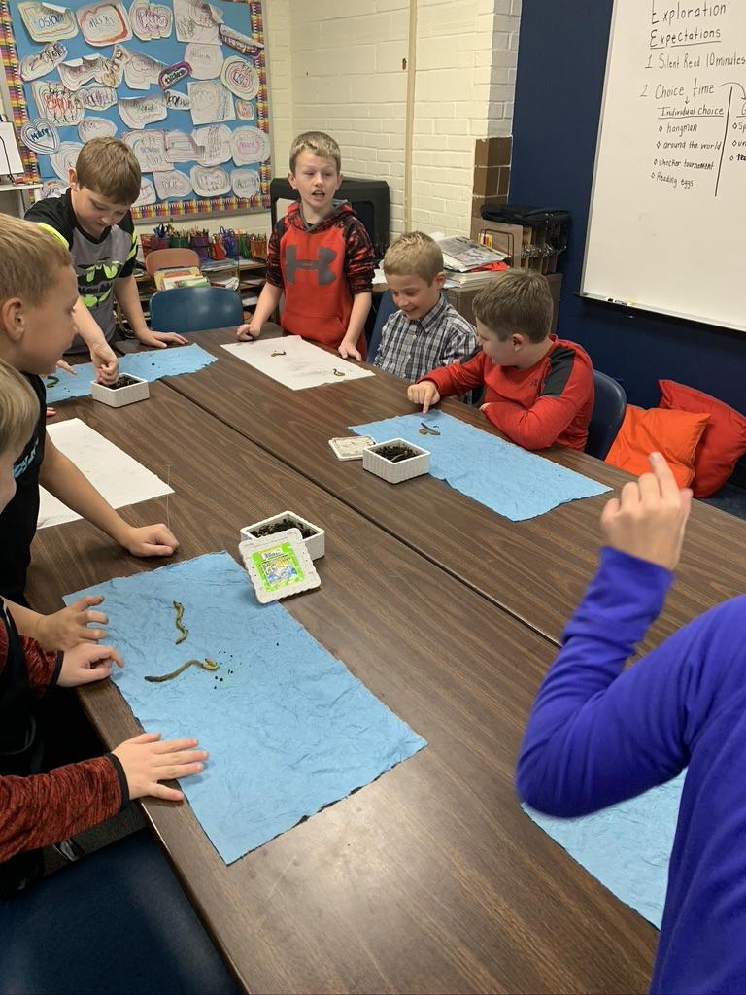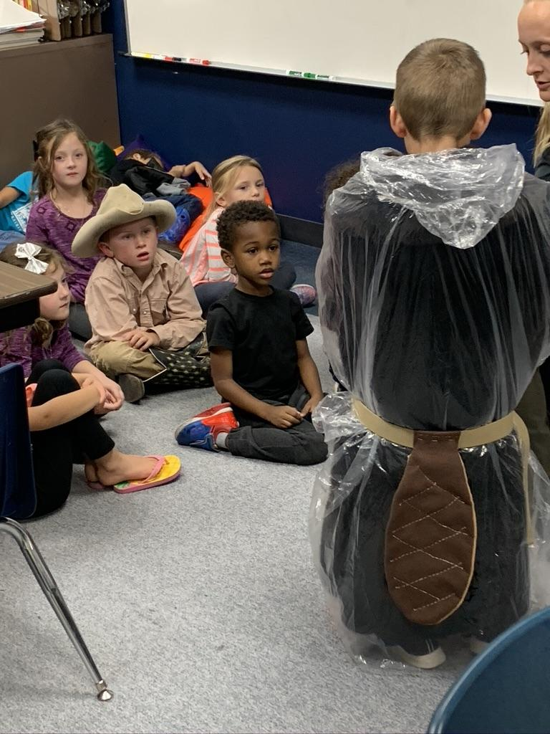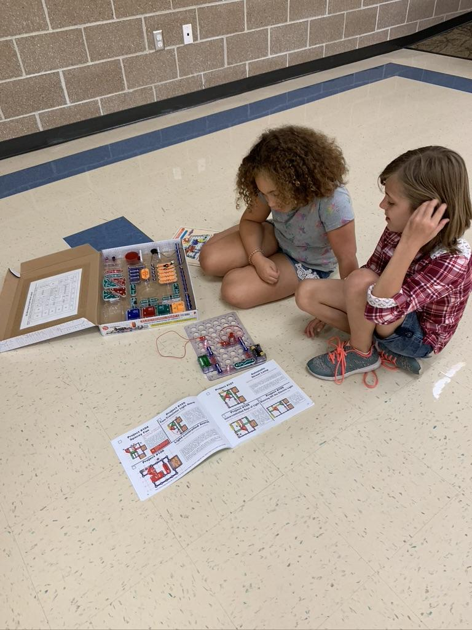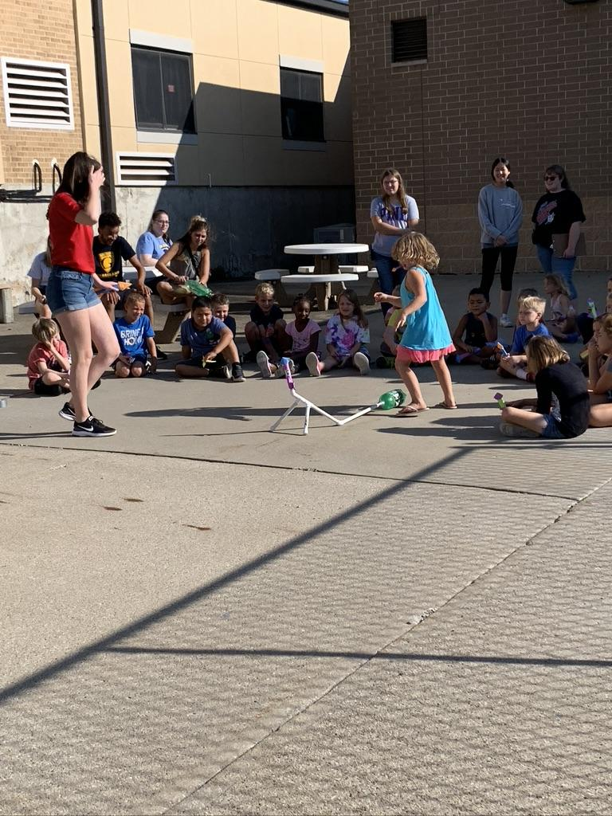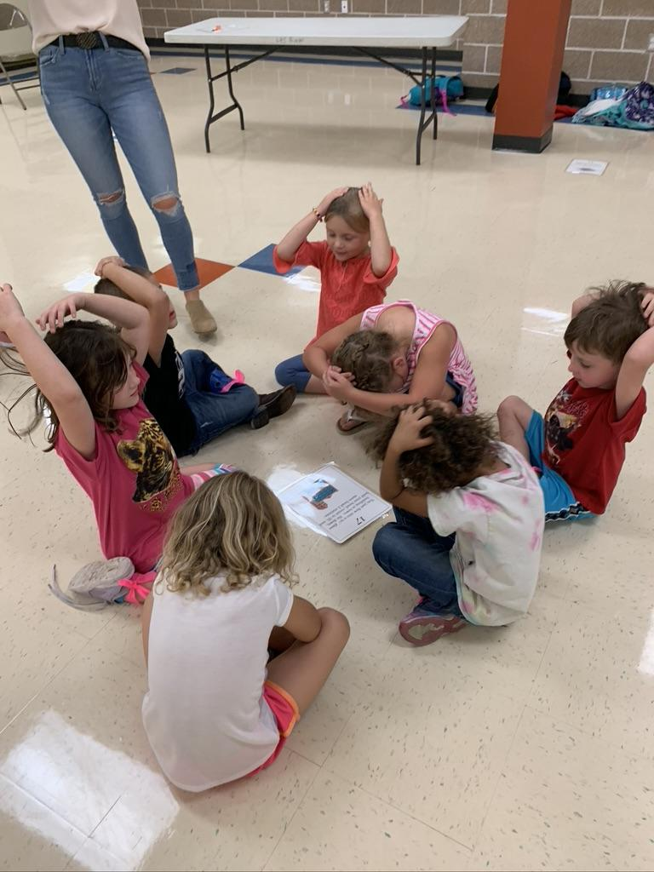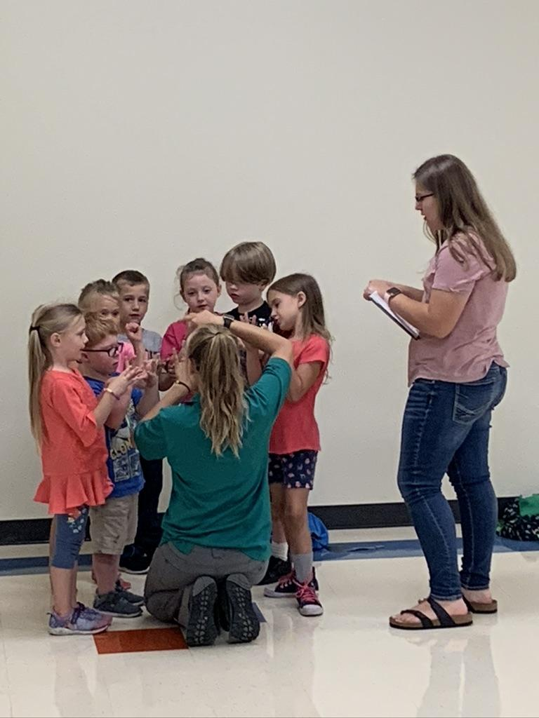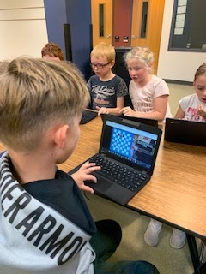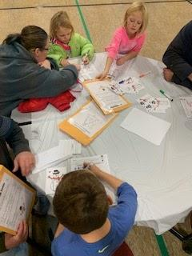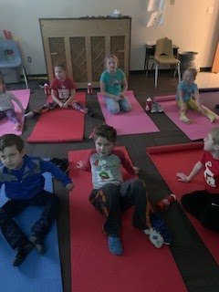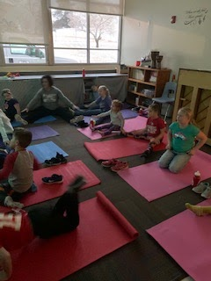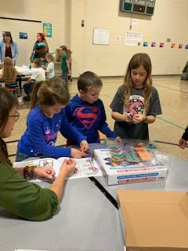
North CM Tuesday Chess Family NIght South Elementary CM Morning Yoga with Public Health STEAM Activities with Graceland Univ.

Student, teacher, parent, and stakeholder input
Student, teacher, parent, and stakeholder input Required Elements | Complete?
Quotes from student, teacher, parent, and stakeholders. | x
Quotes from partners. | x
Quotes should be attributed (titles can be used but names only with permission). | x
Showcase success of the program, especially for student attendance, behavior and academic success. | x

CD
"I love the fact that my son feels safe and enjoys his time at Cardinal muscle. It provides a place for him to grow and learn until I get off work." - Jerri Eakes

“The CCLC program is a GREAT program that not only benefits the children, but working parents!” - Elizabeth Schmidt

Lamoni:
Chelsea Johnson, parent: “I think you are doing a great job. Keep up the great work!”
Parent survey response: “Keep up the great work...one of my kids likes and feels more comfortable at Exploration Academy than at school so I APPRECIATE the kindness and support he gets at Exploration Academy.”
Mormon Trail:
Student: “I like being able to do the fun things Miss Malorie brings with her!” (Miss Malorie is with the Iowa State Extension office)
Parent: “I like that my child is able to get her homework done and we don’t have to worry about it after work!”
6th grade teacher: “Students are held accountable for completing their work. They are more likely to get things done when they attend after school.”
Hannah, Wayne County Naturalist: “Going into the afterschool program has been a great way for me to interact on a more personal level with the kids and their interests in nature. Since the setting and format is a little more open than a regular classroom, we are able to offer more hands-on and experiential programs about natural resources. Kids are also able to help guide the activities a little better by showing their interests so we can spend more time on the parts of the activities that they enjoy most.”

- Sustainability Plans
Sustainability Plans Required Elements | Complete?
Original plan from grant application summary. | x
Discuss formal sustainability plan if applicable. | x
How the program will continue without 21st CCLC grant funding. | x
How partnership contributions will help the program continue (refer to partnership table from section 3). | x

Discuss the level of sustainability over the life of the grant. Explain how partner contributions can help sustain the program after federal funding ends.

Sustainability through program/data analysis: Continuous program improvement starts with vested stakeholders regularly reviewing data and evaluating progress towards the various established goals. The site coordinators and district administrators used data driven evaluation techniques and committed to collaborate on ways to obtain the best possible student learning outcomes. The data was then distributed to key stakeholders for reflection, analysis, and evaluation. Recommendations for changes for improvements followed analysis and interpretation of reports. Student interest in the program was regularly determined by analyzing the attendance patterns as well as aggregating comments from students, staff, and parents during and after program opportunities.
The Decatur County Cares Coalition meets quarterly to review needs and progress of the programs, share resources, and work together in seeking long term sustainability funding.
Sustainability through community partners: Sustainability activities throughout the grant cycle included collaboration with diverse partners to provide an array of quality activities. The activities were designed to intentionally build community awareness of the program in an effort to establish broad community buy-in and to implement a wide range of communication methods to keep critical stakeholders up-to-date about program activities and to engage volunteers and other diversified staff to provide programming. Perhaps the most critical community partner is often the most overlooked and that is the faculty, staff, and administration of each center. Each site coordinator worked to maintain a close relationship with each school district to ensure a connection to the school and the school community to capitalize upon and align with the instructional standards and goals of each.
Sustainability through advocacy: The program centers publicly shared program success and needs with the community at large. District administration advocated with legislative bodies to preserve funding. Central Decatur and the Leon community as well as Graceland and the Lamoni community hosted multiple state and national policymakers in recent years as a part of the ongoing effort to share the positive effects of multiple initiatives.
Sustainability through media: The site coordinators utilized all school and community communication streams to inform the public of the activities and successes of the four program sites. This included postings to social media and more traditional newspaper/newsletter outlets. All marketing efforts were evaluated for their effectiveness in increasing attendance, procuring community support, and identifying potential additional funding streams.
Sustainability through adaptability: Sustainability planning must be creative, flexible and rely on strong partners and internal support. The original design of the program involved a high level of collaboration between the two charter districts to ensure uniform delivery of the program; however, as implementation evolved over the course of the grant cycle, it became clear that each site had its unique needs and program delivery was adapted to accommodate those differences in order to best serve students at each center. As the former grant came to a close the centers looked for ways to continue and expand the program in a way that would impact more students. The Central Decatur and Mormon Trail centers looked for additional partners as they applied for the next grant cycle. As a result, the Decatur County Cares Coalition (DC3) was formed and brought several new stakeholders to the table - including a third school district (Lamoni Community School District). The new program design not only increases the number of students impacted, but the new model significantly increases the collaborative processes of the stakeholders, assembles county-wide resources, increases the potential for additional funding sources, and substantially increases the level of accountability for each learning center. As the newly awarded grant (2017) matures and ultimately ends, other funding streams will have to be pursued. Grant funding is critical to the long-term stability of the DC3 program for all students, as the largest cost in maintaining the program is in staffing. Without grant funding, the programs would become more exclusive, as some type of sliding fee scale would need to be implemented. While family/student fees will ultimately help with sustainability, the DC3 Advisory Board recognizes the impact this would have on the target population - low SES students and families. Currently, 65% of the students qualify for free or reduced lunch, with the majority qualifying for free lunch, and many would be unable to afford even the smallest of fees. The DC3 board members are dedicated to finding outside funding sources to sustain the newly awarded beyond the grant dates.
Sustainability through coordinated resources: The school districts provide space, office equipment, and custodial services. School lunch staff provide healthy snacks under the child care food assistance program. The grant partners worked with daily program staff and the site coordinator to provide assistance and information for programming and family literacy needs. Partners worked to combine resources where possible in order to maximize the positive impact on families and the best utilization of public and private funding.

- Summary and Recommendations
Summary and Recommendations Required Elements | Complete?
Summary of program. | x
Dissemination of local evaluation. | x
Recommendations for local objectives. | x
Recommendations on future plans for change. | x

Summary of Program
Summary of Program Required Elements | Complete?
Reference introduction section. | x
Showcase successes of program. | x
Highlight items contributing to program success. | x
Include exemplary contributions from staff, teachers, volunteers and/or partners. | x

The Decatur County Cares Coalition (Cardinal Muscle, Saints Afterschool Program and Lamoni Exploration Academy) represent a collaborative project resulting from the combined efforts of the Central Decatur Community School District, Lamoni Community School District, and the Mormon Trail Community School District. The partners share resources, responsibilities and risks of the 21st Century program, each contributing to its operations, programming and quality according to individual areas of expertise and mission alignment. The project is closely aligned with district goals, including overall CSIP goals of creating a safe learning environment while increasing math and reading achievement.
This federal grant funding equalizes the opportunity for rural, social and economically disadvantaged students in Decatur County. Transportation and a no-fee structure allows students of all family income levels to participate equally and provides field trips and extended opportunities that would otherwise only be available in more urban settings.

Dissemination of Local Evaluation.
Dissemination of Local Evaluation Required Elements | Complete?
Exact url where local evaluation is posted (required by US DOE). | x
Discussion of other methods of Dissemination (Board reports, community meetings, person to person, e-mail, etc.) | x

https://www.lamonischools.org/vnews/display.v/SEC/Exploration%20Academy%7CLocal%20Evaluation
http://www.centraldecatur.org/north-elementary/cardinal-muscle/
http://www.centraldecatur.org/south-elementary/cardinal-muscle/
http://www.mormontrailcsd.org/wp-content/uploads/2016/03/21st-Century-evaluation-10-28-15.pdf
Highlights from this evaluation are shared annually at the local school board meetings. In addition, paper copies are available and provided to any stakeholder or parent upon request.

Recommendations for Local Objectives.
Recommendations for Local Objectives Required Elements | Complete?
Objectives to be changed and reasons why. | x
Objectives to be added. | x
Include objectives not met. | x
Include objectives not measured. | x

Remember to include an evaluator discussion on how the program met or did not meet the local objectives
The program objectives utilized during the first grant cycle were unrealistic and inadequate when measuring program impact. Beginning in the fall of 2017, Lamoni Community School District was added to the new grant and a joint collaborative advisory board, the Decatur County Cares Coalition, was established to oversee and advise the (now) four centers involved with the project. The board consists of 15 community partners who, collectively, pursue the goal of maximizing resources, partnerships, and opportunities in Decatur County, to serve all Decatur County elementary students and to narrow the achievement gap for students at each of the centers.
With the 2020-2021 school year, the programs will continue to measure and use GPRA milestones to measure progress, and the local objectives written in 2017 will be discontinued.

Recommendations on Future Plans for Change.
Recommendations on Future Plans for Changing Required Elements | Complete?
Changes in activities. | x
Changes in recruitment efforts. | x
Changes in partnerships. | x
Changes for sustainability plans. | x
Other changes as suggested by governing body. | x
Remember to include an evaluator discuss of what can be done to improve the program
Academic performance or achievement is highly examined throughout this evaluation reporting process. One of the key components to academic performance that number data is harder to validate and evaluate is academic behaviors. Academic behaviors have been defined to include going to class, doing homework, organizing materials, participating, and studying. These three programs, Cardinal Muscle, Lamoni Exploration Academy, and Saints Afterschool Program, continue to provide opportunities and pathways for every student, crafting a chance for learning, while strengthening academic behaviors.
As with any evaluation, a deep dive of the programs provided an opportunity to provide recommendations, to assist in further growth and development. The following recommendations for the programs are as follows:
- Changes in activities: Increase elementary school staff participation.
Through conversations during the virtual site visits, all three locations were asked about the fluidity of the program and the school staff. It was discovered that not all locations feel the same support from the elementary staff. As the saying goes, it takes a village. It is important to remember that that village must work together and value the effort each is making, as a member of the same team. It would be great to see all four locations have members of the elementary staff participate, even if it was only for 15 minutes, on a rotation basis.
- Changes in recruitment efforts: Addition of a participant handbook. In the virtual site visits with all four locations, it was discovered that none had a specific handbook for their program. A handbook would help communicate with parents/guardians to specify the goals of the program, as well as outline rules and regulations for behavior, how to enroll in the program, and outline program contact information.
- Changes in partnerships: Create a goal to seek a better gender balance in external partners, as well as, diversity. It is very understandable that a rural area in the state would utilize external partners that are available. These great early experiences and learning opportunities help students imagine what is possible for them to achieve. Seeing, is believing. That is why representation is so important. The COVID-19 closure early last spring has brought about new restrictions, however, it has also provided an opportunity for more virtual presentations, something that might be utilized to address the rural location hurdle and assist the programs in moving forward with more populations/diversity included.
- Changes in sustainability plans: Addition of a monthly calendar communicated with parents/guardians. To many, sustainability means revenue or funding. However, you cannot have these types of programs without students. An addition of a monthly calendar will aid in attendance, retention, and productivity. Schedules or calendars, help students visualize a routine. A published monthly calendar could assist with productivity, help students and families prioritize the program, and encourage students to stay on task. It will also assist parents/guardians with continuing conversations/learning at home.
- Other changes: College and career readiness.
The four programs have great external partners that assist with presentation for the students. It would be great to include a focus on college and career readiness, in a lens that helps students see that learning is lifelong. If the external partners could speak on the pathway to their career that they took, students could make a direct connection between class curriculum and the world of work. It would also help students see how their classroom strengths or interests align with a career.
Ideas and reflections from program directors are included below.
Mormon Trail- I would like to incorporate more involvement with the community. With COVID, we have had to cut back on the involvement. This year, we have been able to offer classes to students on Fridays when we do not have school. There was a hunter safety course and a self-defense class. We would like to continue to offer these opportunities to our students.
Lamoni- I too would like more community involvement. COVID really halted some great things we were doing. We had started Yoga once a week with a great instructor and had noticed a difference in the students. I would like to get more school staff and teachers involved. We collaborate with Family Nights but would also like to see some day to day involvement.
CD- We miss our Community Partners coming to our buildings. We have been in touch with our partners and they have given us ideas and/or materials but it is not the same when the students can hear from the experts in person.

UNEXPECTED DATA (Unusual circumstances that occurred during the past school year- Flood, Tornado, Storm, Pandemic or other) Explain how this affected the program and how you responded to continue to serve children. What new procedures did you introduce? How did the Staff, Students and Parents respond? You may include pictures to help illustrate the challenges faced because of natural disaster.
Lamoni- During the spring when we were closed down, I continued to reach out to parents and grandparents of our program students to assist any needs they may have had. I provided parents with login information for our Math and Reading programs. I served the lunches daily to keep in contact with parents and students. I delivered lunches to a family without transportation. Our parents were grateful for the support. It was reassuring to keep eyes on kids and make small connections. When we were allowed to start in July with a summer program, parents were supportive and we had a good response. We adjusted the hours, cancelled field trips, took temps daily, and kept the groups small. This fall we have utilized the good weather to be outside as much as possible. We continue to have good numbers utilizing the program.
Mormon Trail- When we shut down in the spring, lunches were prepared for families in both Humeston and Garden Grove. Students had access to multiple online resources, both through classroom teachers and myself. We did not operate a summer program. This year has brought its own challenges, however we have been able to improve our program. Our district does not allow visitors in the building, so we have had to be creative with program partners. We use Zoom with our naturalist once a month. Mormon Trail does not have school on Friday, so we have been able to offer full day classes the students can sign up. We have offered a self-defense class (students were able to spread out) and a hunter safety course offered outside.
Central Decatur- When the COVID crisis resulted in the schools closing down in March so did all of our extra programming. Through efforts from the school we continued to provide breakfast and lunch to our students and to the other small towns in our district. Through the food distribution the food trucks also distributed academic packets for students to the towns outside our city limits. This ensured that all students had access to food and academics on a regular basis. Now that the new school year has begun our before and afterschool programing has started up again. We have our students in specific grade level groups working with the same adults in order to control the spread of the virus. We are not allowing visitors so we have participated in on-line live STEM sessions that have been very engaging for our students. Our morning program has been revamped to have centers for physical movement and self regulation. The materials were supplied by Public Health.

